Sal f
Golden Valley High School
Wm. S. Hart Union High School District
“Home of the Grizzlies”
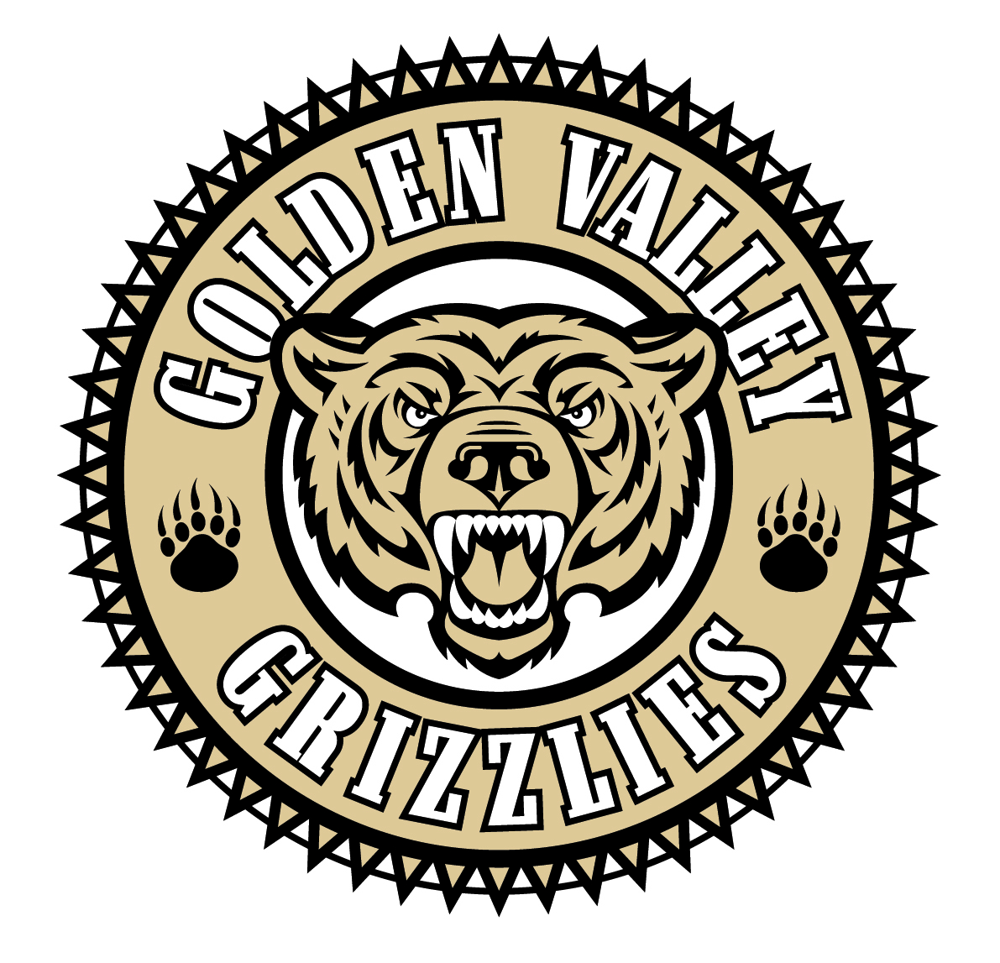
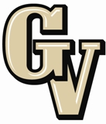

Parent Advisory Council (PAC) Meeting
November 25, 2013
6:30 PM

AGENDA

- PAC Meeting Welcome Sal Frias

- Secretary’s Report ACTION Jennifer Ryan

- Treasurer’s Report ACTION Emily Curtis

- President’s Report Sue Alterman

- WiSH Foundation Update Amy Daniels

- District Advisory Council (DAC) Report Monica Camacho

- Parent Communications Council (PCC) Report Cherise Moore

- Introduction of New Principal at La Mesa Michele Krantz

- Demographic Data Sal Frias

- Athletic Department Presentation Sal Frias

- Finals Schedule Changes for 2013-14 Sal Frias

- Common Core Update Sal Frias

Announcements: -No school on Nov. 28th and 29th (Happy Thanksgiving)
-ASB Movie Night on Tuesday, Dec. 3rd.
-GV Band Chili’s Night on Wednesday, Dec. 4th.
-AFJROTC Military Ball on Thursday, Dec. 5th.
-Choir Winter Concert on Wednesday, Dec. 11th.
-Band Winter Concert on Friday, Dec. 13th.
-Finals on Dec 17, 18, and 19th.
-Non student work day on Friday, Dec 20th.
-School resumes Monday, January 13, 2014.
-Martin Luther King Day on 1/20/14.

Next Meeting: January 27, 2014

The mission of GVHS is to provide a quality education to a diverse student population, develop each student’s maximum potential, and prepare students for success in the global community.

